**NAME:…………………………………...………………… STREAM………………..**

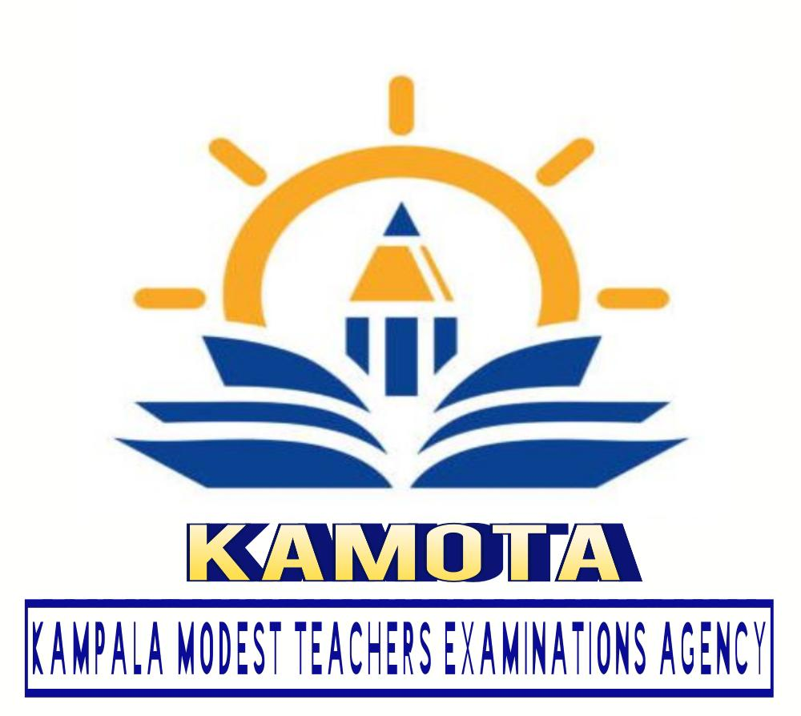

**KAMOTA EXAMINATIONS COMMITTEE**

MID TERM I EXAMS, 2024

SENIOR TWO CRE

Time: 2 hrs.

**INSTRUCTION:**

* Answer all questions

1. a) Give the meaning of the word Human dignity (2mks)

**………………………………………………………………………………………………………………………………………………………………………………**

1. Mention five elements of human dignity you know (05mks)

**………………………………………………………………………………………………………………………………………………………………………………………………………………………………………………………………………………………………………………………………………………………………………………………………………………………………………………………**

1. Give five examples of respect of human dignity at school. (5mks)

**………………………………………………………………………………………………………………………………………………………………………………………………………………………………………………………………………………………………………………………………………………..……………**

1. a) Explain what it being human? (3mks)

**………………………………………………………………………………………………………………………………………………………………………………**

b) Mention at least five examples of being human? (5mks)

**(i)……………………………………………………………………………………**

**(ii)……………………………………………………………………………………**

**(iii)………………………………………………………………………………… iv)……………………………………………………………………………………**

**(v)……………………………………………………………………………………**

**(vi)………………………………………………………………………………… (vii)…………………………………………………………………………………**

**(viii)…………………………………………………………………………………**

1. a) what is marriage (2mks)

**........................................................................................................................................................................................................................................................................**

b) Explain how marriage ritual bring people together (8mks)

**……………………………………………………………………………………………………………………………………………………………………………………………………………………………………………………………………………………………………………………………………………………………………………………………………………………………………………………………………………………………………………………………………………………………………………………………………………………………………………………………………………………………………………………………………………………………………………………………………………………………………………………………………………………………………………… ………………………………………………………………………………………………………………………………………………………………………………………………………………………………………………………………………**

END